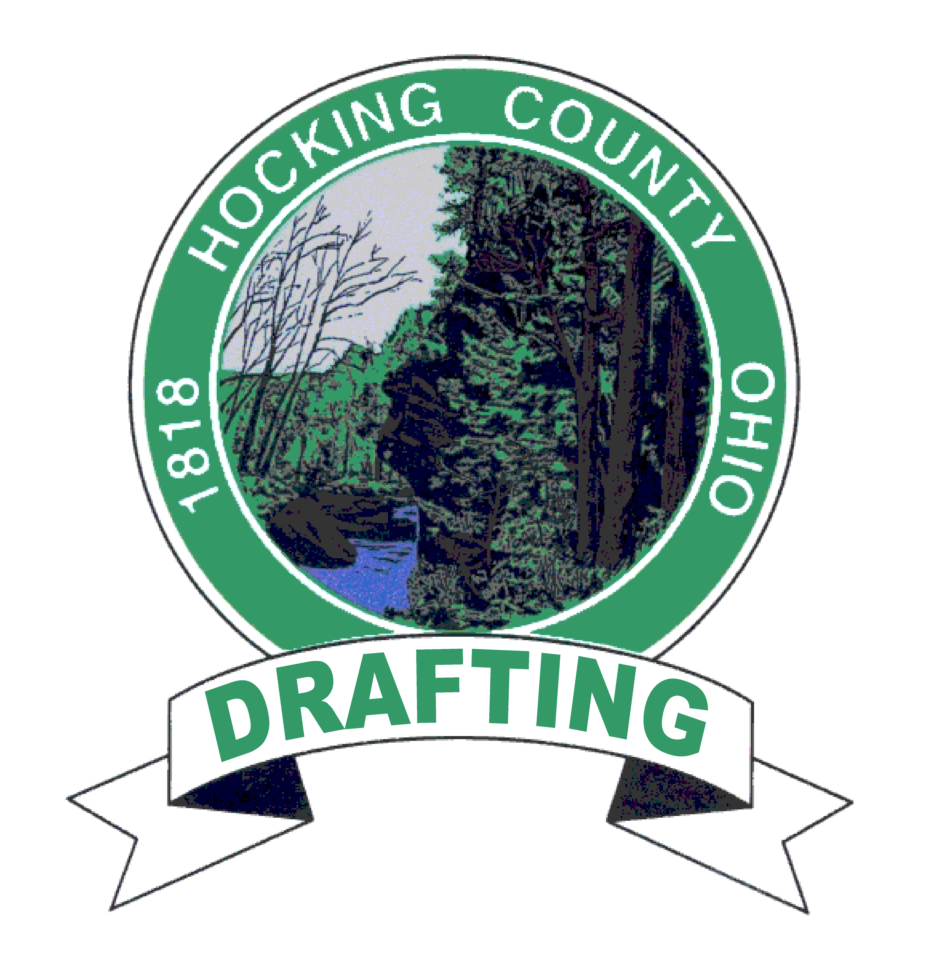
FRANK NELSON - Head Draftsman
fnelson@co.hocking.oh.us

WESLEY BARBER – Draftsman CHARLES WORTHINGTON - Draftsman
wbarber@co.hocking.oh.us cworthington@co.hocking.oh.us

Hocking County Drafting Department - 1 East Main Street - Logan, Ohio 43138

Phone: (740) 385-8546 Tax Maps: www.co.hocking.oh.us Fax: (740) 385-8547

10-15-2009

RE: INTERNET AERIAL PHOTOGRAPHY

In 2007 Aerial Imagery was captured for the entire State of Ohio. These images are distributed by OGRIP (Ohio Geographically Referenced Information Program) in Mr. Sid file format and can be downloaded from the County FTP Site at www.co.hocking.oh.us or directly from OGRIP at http://gis4.oit.ohio.gov/osiptiledownloads/default.aspx .
To be able to read the Mr. Sid files, LizardTech offers “Geoviewer 4.0” and also offers browser plug-ins to view the imagery through a web browser. These are available by download for free at http://www.lizardtech.com/download/dl_options.php?page=viewers .

Frank Nelson, Head Draftsman
Wesley Barber, Draftsman
Charles Worthington, Draftsman
Hocking County Drafting Department

http://gis4.oit.ohio.gov/osiptiledownloads/default.aspx

